Тема: | Подорож до Великої Британії
Мета: | - практична: систематизувати та узагальнити вивчений матеріал за темою «Велика Британія», вдосконалювати навички говоріння та аудіювання;  - освітня: розширити знання учнів про Сполучене Королівство Великої Британії та Північної Ірландії;  - розвиваюча: розвивати творчі здібності, кмітливість школярів, вміння спілкуватися англійською мовою;  - виховна: виховувати у школярів мотивацію до оволодіння іноземною мовою та потребу в залученні до світової культури
Клас: | 9
Обладнання: | мультимедійна презентація, роздатковий матеріал, кольорові олівці, папір для малювання
Форма проведення: Урок-вікторина

Хід уроку
І етап. Організаційний. Вступне слово вчителя. Повідомлення цілей уроку.
Teacher. | Good afternoon, dear pupils and jury. Today we shall experience an imaginary travel to the United Kingdom of Great Britain and Northern Ireland and do it with the help of an interesting game. It will help you to review the material you have studied at your English lessons and I hope you will get to know many new interesting things. The contest consists of 8 tasks including your presentations you should have prepared beforehand.  Before starting the game let me introduce the members of the jury (teachers of English), teams and their captains.

ІІ етап. Основний.
Teacher. | Before we start, I invite the captains to present the mottoes of their teams (капітани команд презентують девізи)  Thank you very much. Let us start the game.

Task 1. Countries and their symbols
Teacher. | Match the parts of the United Kingdom with their national flowers.  The team which completes the task first will answer first and get one point (Handout 1)  (England – Tudor rose  Scotland – Thistle  Wales – Leek  Northern Ireland – Shamrock)

Task 2. Quiz.
Teacher. | One by one, answer the questions. Be attentive, as the success of your team depends on your answer (1 point for each correct answer).

- What is the longest river in the UK? (The Severn)
- What is the capital city of Scotland? (Edinburgh)
- What is the name of the channel between England and France? (The English Channel)
- What is the highest mountain in the UK? (Ben Nevis)
- What is the current Queen's name? (Elizabeth II)
- What is the name of the famous stadium in the north of London? (Wembley)
- What is the name of the lake in which a monster is supposed to live? (Loch Ness)
- Who is the author of the fictional stories about Sherlock Holmes? (Sir Arthur Conan Doyle)
- Which famous writer was born in Stratford-upon-Avon? (William Shakespeare)
- What is the oldest University in Britain? (The University of Oxford)
- Who is the patron saint of England? (St. George)
- How is the flag of United Kingdom called? (Union Jack)
- How many years did the Hundred Years War last? (116 years)
- Who is the current Prime Minister? (David Cameron)
- Who is the patron saint of Scotland? (St. Andrew)
- What is the name of the street where the Prime Minister lives? (Downing Street)
- How many faces does Big Ben have? (Four)
- What is the capital city of Wales? (Cardiff)
- How many chambers does the British Parliament consist of? (Two)
- Who is the famous British criminal female writer? (Agatha Christie)
- What is the second largest city in the UK after London? (Birmingham)
- Whose statue stands on the column in the middle of Trafalgar Square? (Lord Admiral Nelson)
- Which great London cathedral was built by Sir Christopher Wren? (St Paul's Cathedral)
- What is the popular name for London's Underground? (The Tube)
- Where does the Queen live? (in Buckingham Palace)
- Which of the four parts is not represented on the flag of the UK? (Wales)
- What is the Roman name for Scotland? (Caledonia)
- When is Halloween celebrated? (on October, 31)
- Who is the author of the books about Harry Potter? (Joan Rowling)
- What river does London stand on? (The Thames)

Task 3. Drawing contest
Teacher. | Now take your pencils and sheets of paper and get ready to draw. I invite the captains to draw cards with the task. You should draw the answer three minutes (maximum 3 points for each team).

- A national flower of England
- A national flower of Scotland
- St. George’s cross
- Flag of the UK

Task 4. Test in Geography.
Teacher. | Let us check how good in geography you are. Each team gets an outline map and should mark on it:  - Parts of the UK (4 points if correct)  - Capital cities (4 points if correct)  - The English Channel (1 point if correct)  - The Thames (1 point if correct)  - The Severn (1 point if correct)  (maximum 11 points for each team).

Task 5. Game with the audience.
Teacher. | While the teams are doing the task I shall ask the audience several questions. Raise your hand, answer the question. If the answer is right, you may give a point to the team you choose (1 point for each correct answer)

- What parts does the United Kingdom consist of? (England, Scotland, Wales and Northern Ireland)
- What is the capital of Wales? (Cardiff)
- What is the population of London? (above 8 million people)
- What is the name of Shakespeare’s theatre? (the Globe)
- What are the two famous university towns in England? (Oxford and Cambridge)

Task 6. Photo contest
Teacher. | Look at the photos and in turns tell what it is. The leading team starts the task. If the team fails to answer, the opposite team has a chance to answer and get a point (2 points for each correct answer)  (Stonehenge, the Beatles, Queen Elizabeth, Big Ben, Margaret Thatcher, London Eye, Tower Bridge, a double-decker, Houses of Parliament, Buckingham Palace, Wembley Stadium, Wimbledon, Westminster Abbey, William Shakespeare, Queen's Guard, Tudor rose)

Task 8. Homework.
Teacher. | Your homework was to prepare a presentation London, the capital city of the UK (maximum 10 points for each team).

ІІІ етап. Заключний. Підведення підсумків позакласного заходу.
Teacher. | Now, let us sum up the scores  The score of the first team is…  The score of the second team is…  So, the winner is the team …  Our congratulations, thanks a lot to all the participants of the competition.

Handout 1
England | Leek  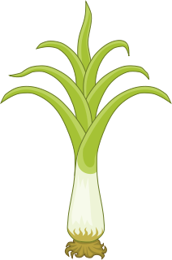
Scotland | Shamrock  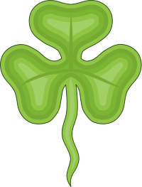
Wales | Thistle  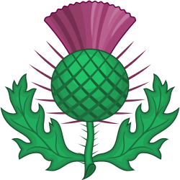
Northern Ireland | Tudor rose  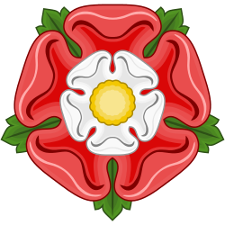

Handout 2

